Christian Claudio

CS-330

June 22, 2025

**Final Project Reflection**

For my project, I chose to use the scene below as the model for my rendered scene:

* 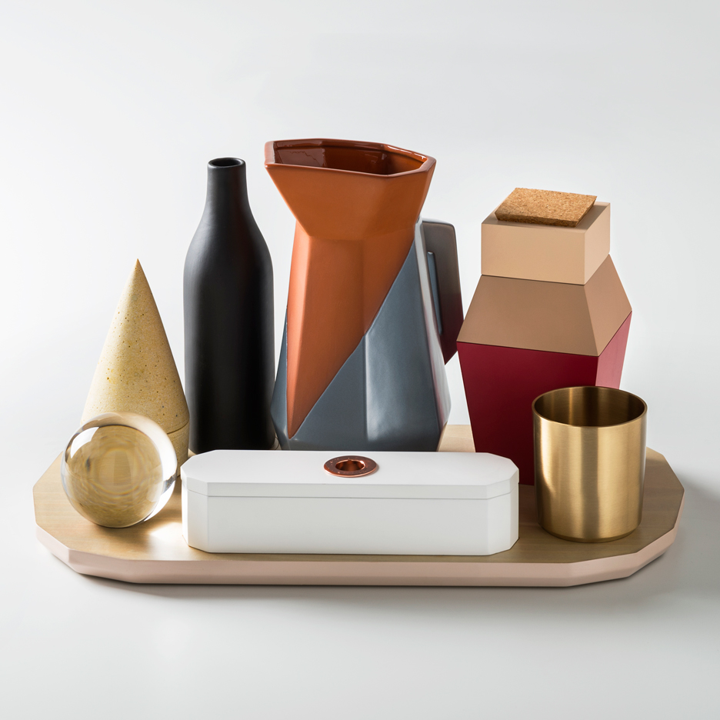

**Objects:**

In order to create the scene, I used a variety of shape meshes to achieve the desired

resemblance. For the sugar container on the back left, I used boxes and a pyramid. I did this to emulate the slanted appearance of the mid-section of the container and applied textures that matched the color as much as possible and changed the lighting and material as such. For the cork on the top, I applied a cork texture. For the bottle, I used the same technique, using a tapered cylinder and two cylinders to attempt to mimic the shape in the image and applied a black stone texture.

For the cup, I used a single cylinder and made the top open by using the following technique: m_basicMeshes->DrawCylinderMesh(false, true, true). Doing this allowed me to render the cylinder without the top and it appeared as a cup. I did this same thing with the pot and bottle to give the appearance of an open container. The coffee pot utilized an inverted tapered cylinder for the top, a tapered cylinder for the main body, a standard cylinder for the base. I applied a brushed steel texture to the main body and base while using an orange texture for the top to emulate a similar appearance to the image. I also created a handle using two rotated boxes.

The glass sphere was a little bit of a challenge, I had to change the color values to be translucent and had the lighting values set to give it a more blue “glass like” appearance while increasing the spectral/shininess value to make it shinier than the other objects. As a result of using SetShaderColor(), I did not apply a texture to this object. The result was satisfying and I am happy about the way it looks. For the container I used two boxes and 5 cylinders. I did this to match the shape of the one in the image and so it appeared to have a lid with a copper knob on it. Finally, the cone object (I couldn’t really figure out what exactly it was) utilized a cone and a half sphere to emulate the object in the image. I re-used the cork texture for this one and give the material a more matte appearance with increased diffuse light value and decreased shininess.

**Navigation:**

Scene Navigation is done as follows:

* Pressing P changes the camera to perspective view.
* Pressing O changes the camera to a frontal orthographic view
* Pressing W zooms the camera in to the scene.
* Pressing A zooms the camera out from the scene.
* Pressing S moves the camera to the right.
* Pressing D moves the camera to the left.
* Pressing Q moves the camera up.
* Pressing E moves the camera down.
* Using the mouse scroll wheel forward increases the speed of movement while scrolling backward decreases the movement speed.
* Finally, moving the mouse cursor will move the camera around in place.

**Coding Practices Used:**

While writing the code, I was able to re-use the format of each rendered object. Doing this, I copy and pasted an object and renamed the function call to draw and changed position/scale values to the desired object and values. This made the process of creating the scene much easier.

**Screenshots:**

Orthographic:

Perspective:

Side Orthographic:

Top Orthographic:

